EX NO: 21 HOSPITAL MANAGEMENT SYSTEM

USECASE DIAGRAM:

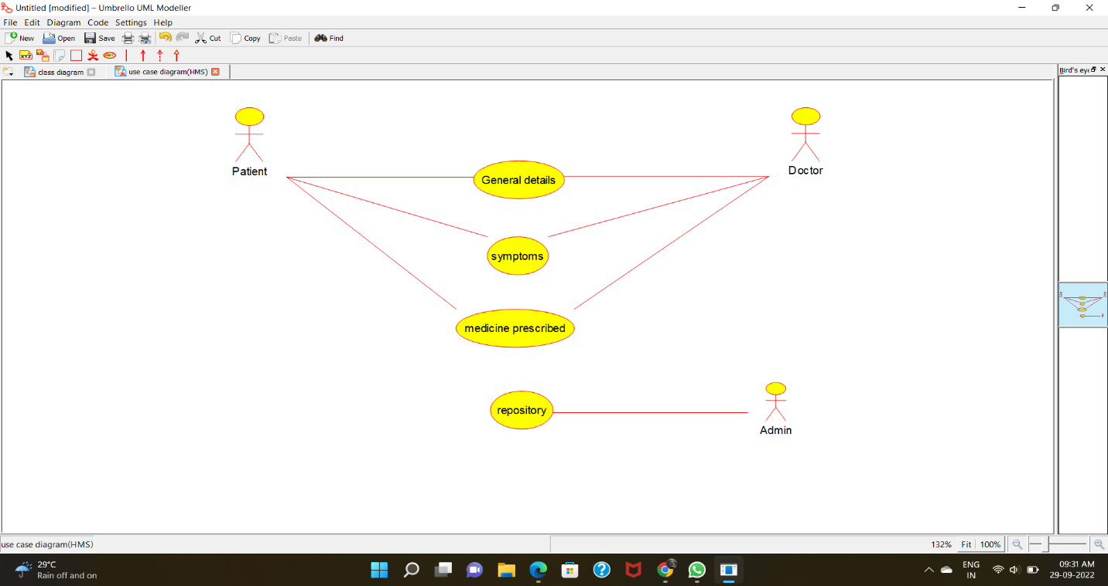

CLASS DIAGRAM: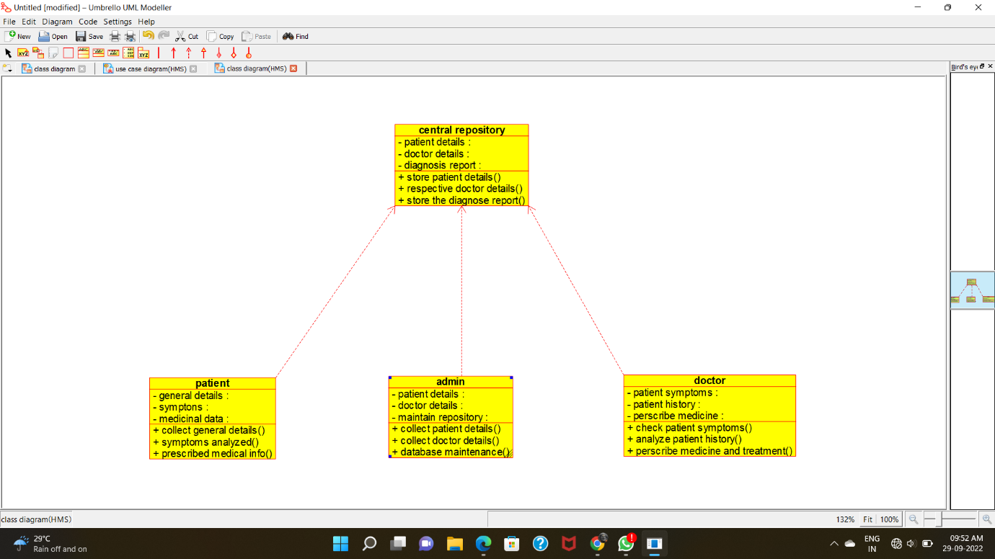

ACTIVITY DIAGRAM:

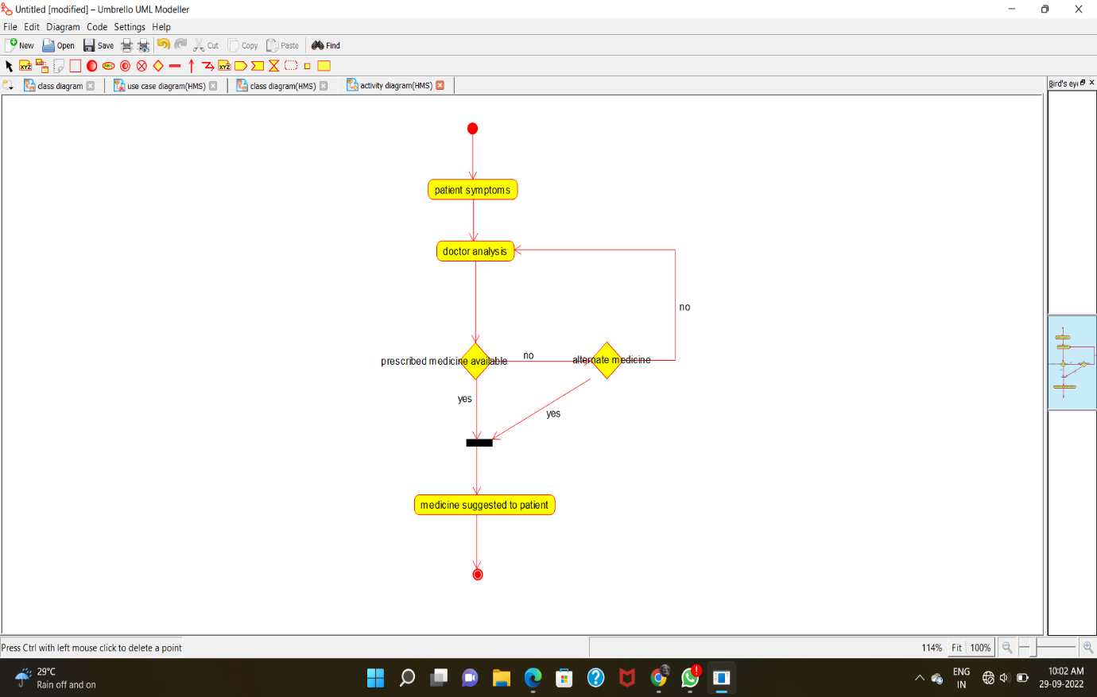

SEQUENCE DIAGRAM: 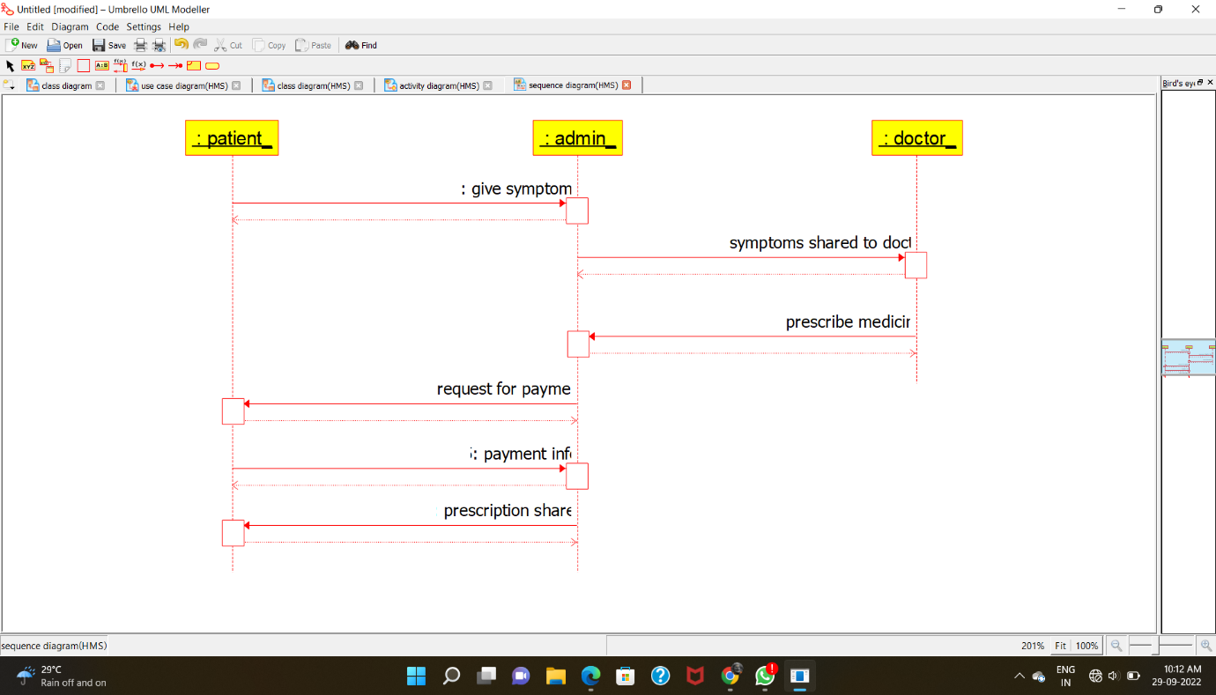

COLLABRATION DIAGRAM:

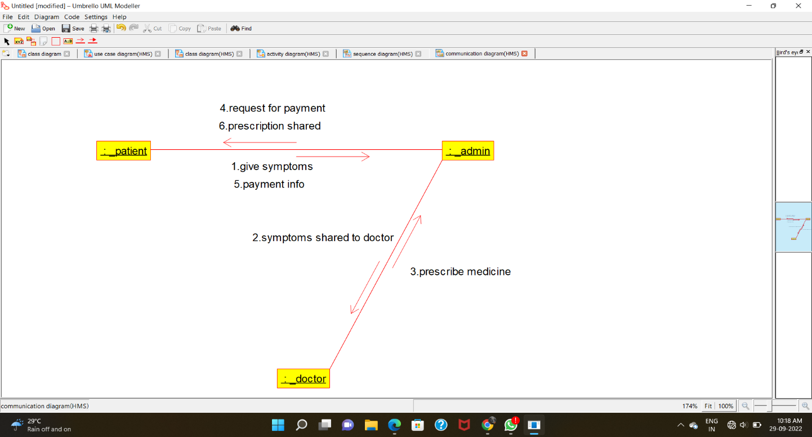

STATE-CHART DIAGRAM:

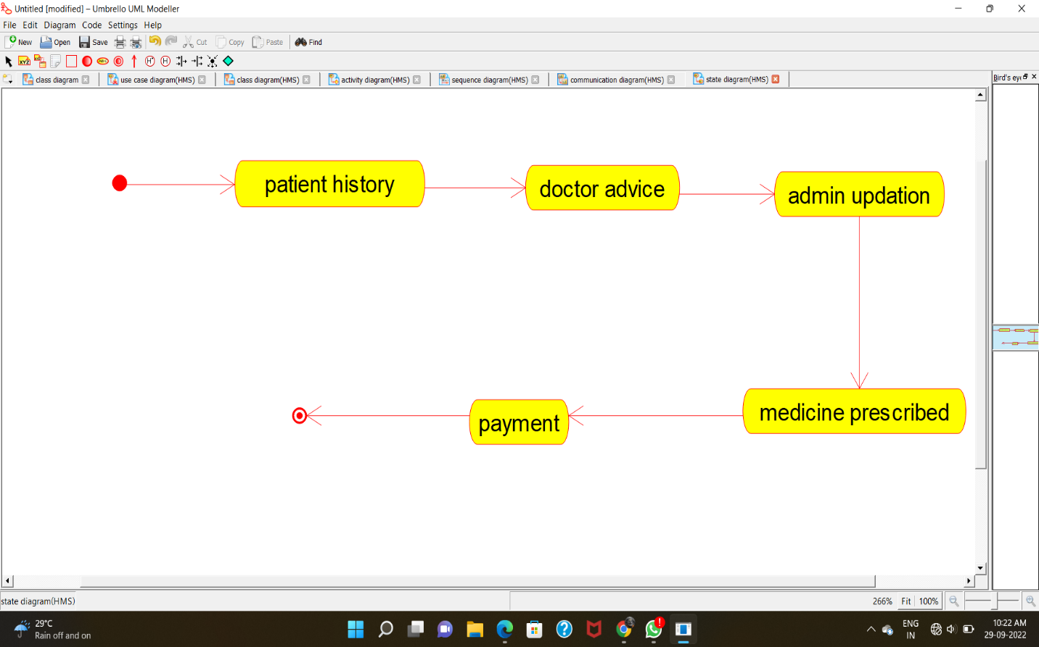

COMPONENT DIAGRAM:

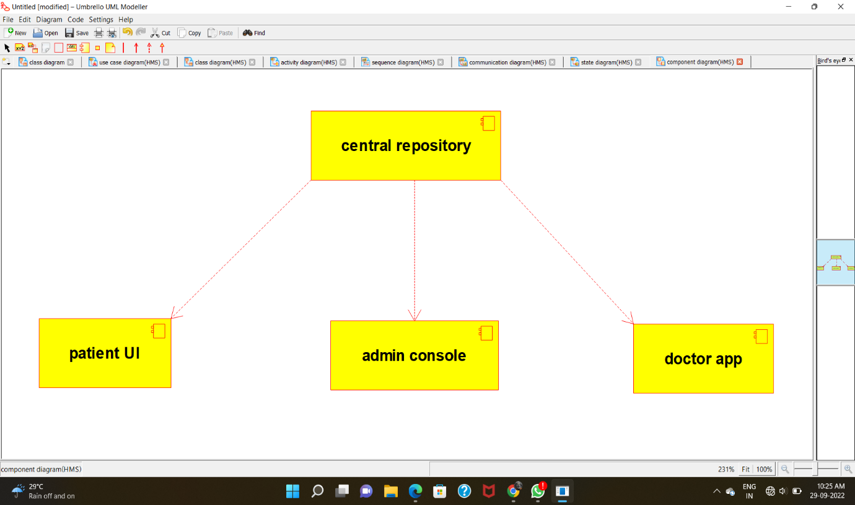

DEPLOYMENT DIAGRAM:

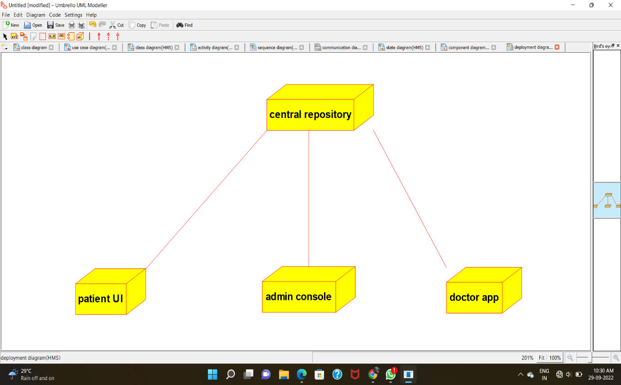

PROGRAM CODE:

CENTRAL REPOSITORY:

/**

* Class central_repository

*/

public class central_repository {

//

// Fields

//

private void patient_details;

private void doctor_details;

private void diagnosis_report;

//

// Constructors

//

public central_repository () { };

//

// Methods

//

//

// Accessor methods

//

/**

* Set the value of patient_details

* @param newVar the new value of patient_details

*/

private void setPatient_details (void newVar) {

patient_details = newVar;

}

/**

* Get the value of patient_details

* @return the value of patient_details

*/

private void getPatient_details () {

return patient_details;

}

/**

* Set the value of doctor_details

* @param newVar the new value of doctor_details

*/

private void setDoctor_details (void newVar) {

doctor_details = newVar;

}

/**

* Get the value of doctor_details

* @return the value of doctor_details

*/

private void getDoctor_details () {

return doctor_details;

}

/**

* Set the value of diagnosis_report

* @param newVar the new value of diagnosis_report

*/

private void setDiagnosis_report (void newVar) {

diagnosis_report = newVar;

}

/**

* Get the value of diagnosis_report

* @return the value of diagnosis_report

*/

private void getDiagnosis_report () {

return diagnosis_report;

}

//

// Other methods

//

/**

*/

public void store_patient_details()

{

}

/**

*/

public void respective_doctor_details()

{

}

/**

*/

public void store_the_diagnose_report()

{

}

}

**PATIENT:**

/**

* Class patient

*/

public class patient {

//

// Fields

//

private void general_details;

private void symptons;

private void medicinal_data;

//

// Constructors

//

public patient () { };

//

// Methods

//

//

// Accessor methods

//

/**

* Set the value of general_details

* @param newVar the new value of general_details

*/

private void setGeneral_details (void newVar) {

general_details = newVar;

}

/**

* Get the value of general_details

* @return the value of general_details

*/

private void getGeneral_details () {

return general_details;

}

/**

* Set the value of symptons

* @param newVar the new value of symptons

*/

private void setSymptons (void newVar) {

symptons = newVar;

}

/**

* Get the value of symptons

* @return the value of symptons

*/

private void getSymptons () {

return symptons;

}

/**

* Set the value of medicinal_data

* @param newVar the new value of medicinal_data

*/

private void setMedicinal_data (void newVar) {

medicinal_data = newVar;

}

/**

* Get the value of medicinal_data

* @return the value of medicinal_data

*/

private void getMedicinal_data () {

return medicinal_data;

}

//

// Other methods

//

/**

*/

public void collect_general_details()

{

}

/**

*/

public void symptoms_analyzed()

{

}

/**

*/

public void prescribed_medical_info()

{

}

}

**ADMIN:**

/**

* Class admin

*/

public class admin {

//

// Fields

//

private void patient_details;

private void doctor_details;

private void maintain_repository;

//

// Constructors

//

public admin () { };

//

// Methods

//

//

// Accessor methods

//

/**

* Set the value of patient_details

* @param newVar the new value of patient_details

*/

private void setPatient_details (void newVar) {

patient_details = newVar;

}

/**

* Get the value of patient_details

* @return the value of patient_details

*/

private void getPatient_details () {

return patient_details;

}

/**

* Set the value of doctor_details

* @param newVar the new value of doctor_details

*/

private void setDoctor_details (void newVar) {

doctor_details = newVar;

}

/**

* Get the value of doctor_details

* @return the value of doctor_details

*/

private void getDoctor_details () {

return doctor_details;

}

/**

* Set the value of maintain_repository

* @param newVar the new value of maintain_repository

*/

private void setMaintain_repository (void newVar) {

maintain_repository = newVar;

}

/**

* Get the value of maintain_repository

* @return the value of maintain_repository

*/

private void getMaintain_repository () {

return maintain_repository;

}

//

// Other methods

//

/**

*/

public void collect_patient_details()

{

}

/**

*/

public void collect_doctor_details()

{

}

/**

*/

public void database_maintenance()

{

}

}

DOCTOR:

/**

* Class doctor

*/

public class doctor {

//

// Fields

//

private void patient_symptoms;

private void patient_history;

private void perscribe_medicine;

//

// Constructors

//

public doctor () { };

//

// Methods

//

//

// Accessor methods

//

/**

* Set the value of patient_symptoms

* @param newVar the new value of patient_symptoms

*/

private void setPatient_symptoms (void newVar) {

patient_symptoms = newVar;

}

/**

* Get the value of patient_symptoms

* @return the value of patient_symptoms

*/

private void getPatient_symptoms () {

return patient_symptoms;

}

/**

* Set the value of patient_history

* @param newVar the new value of patient_history

*/

private void setPatient_history (void newVar) {

patient_history = newVar;

}

/**

* Get the value of patient_history

* @return the value of patient_history

*/

private void getPatient_history () {

return patient_history;

}

/**

* Set the value of perscribe_medicine

* @param newVar the new value of perscribe_medicine

*/

private void setPerscribe_medicine (void newVar) {

perscribe_medicine = newVar;

}

/**

* Get the value of perscribe_medicine

* @return the value of perscribe_medicine

*/

private void getPerscribe_medicine () {

return perscribe_medicine;

}

//

// Other methods

//

/**

*/

public void check_patient_symptoms()

{

}

/**

*/

public void analyze_patient_history()

{

}

/**

*/

public void perscribe_medicine_and_treatment()

{

}

}

**USE CASE DIAGRAM:**

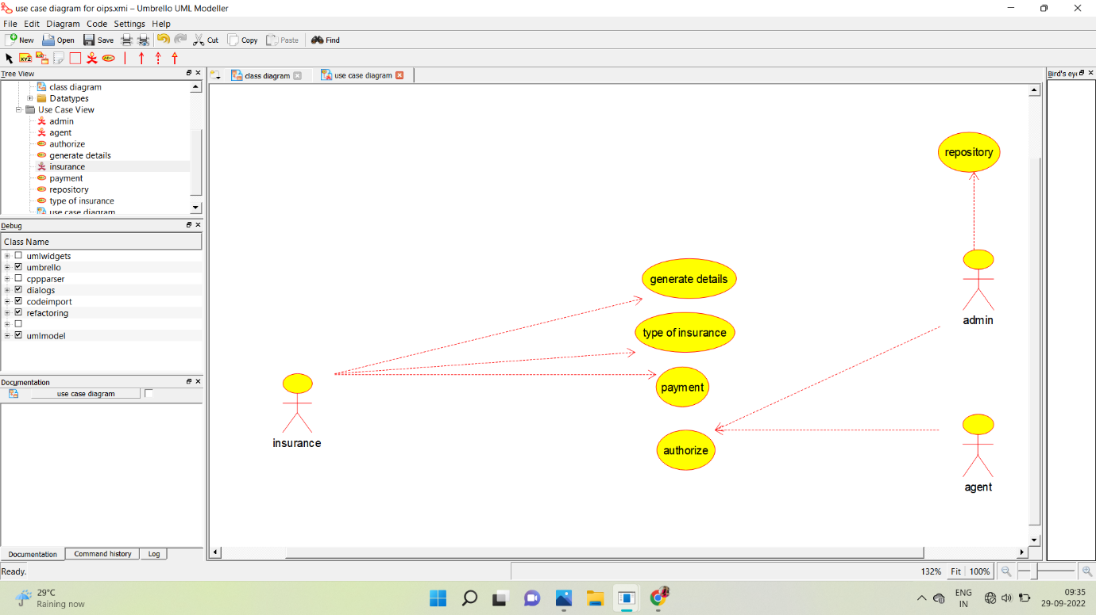

**CLASS DIAGRAM:**

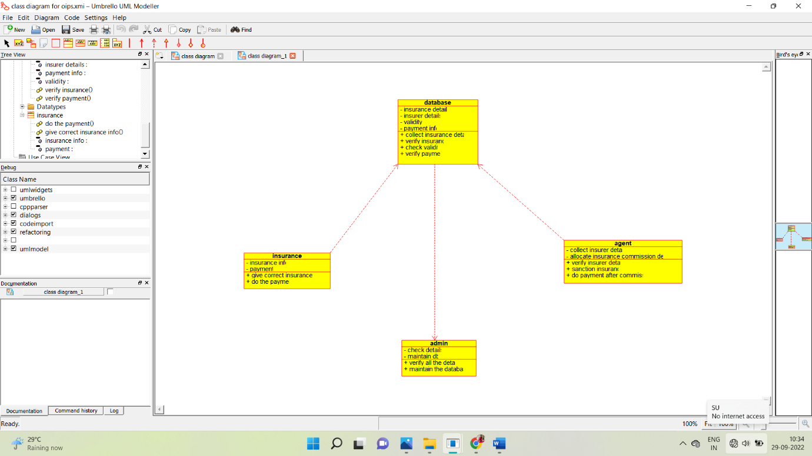

**ACTIVITY DIAGRAM:**

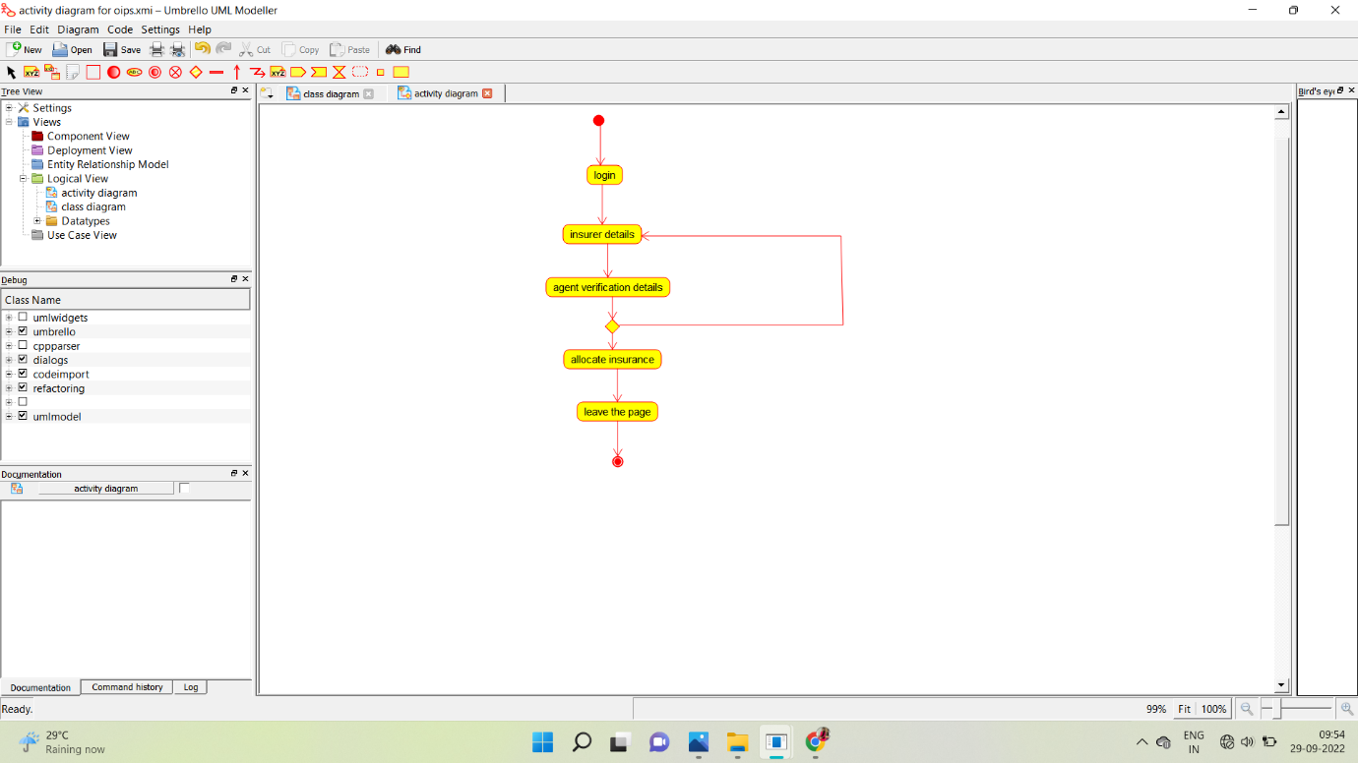

**SEQUENCE DIAGRAM:**

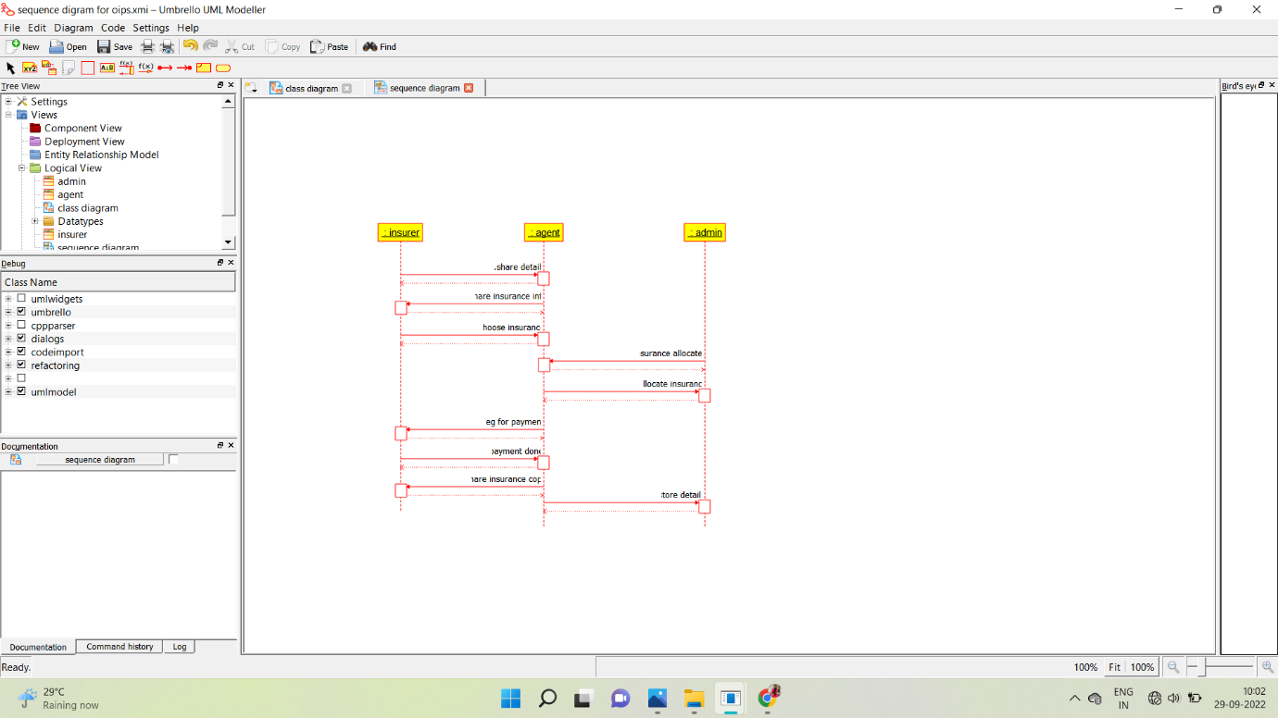

**COLLABORATION DIAGRAM:**

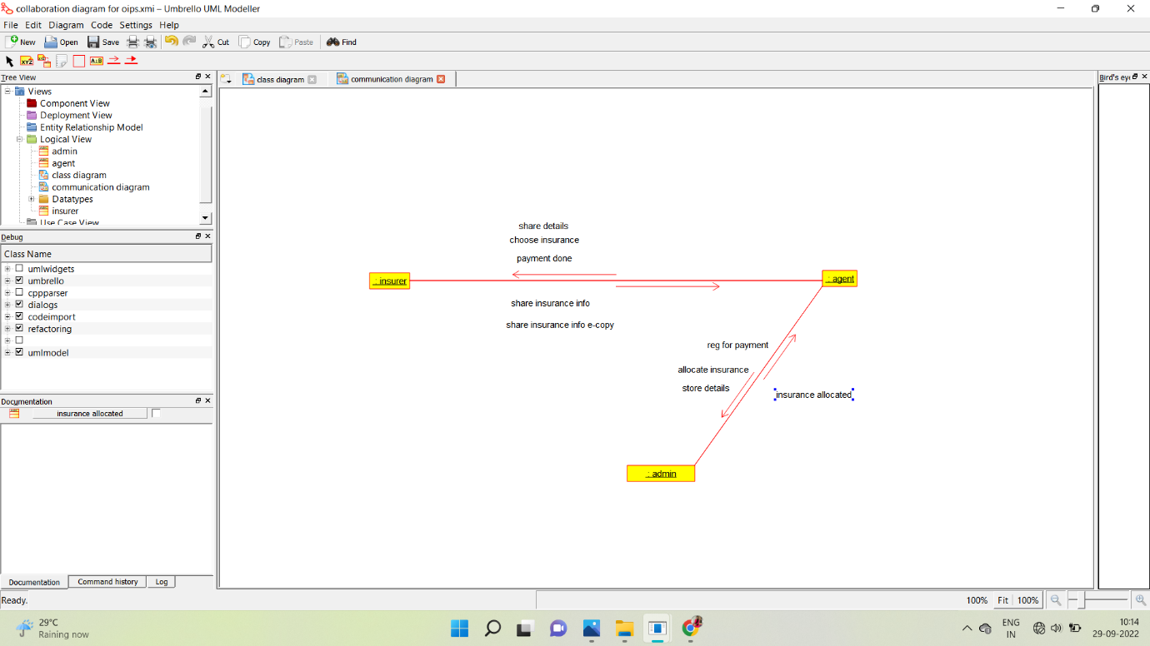

**STATE CHART DIAGRAM:**

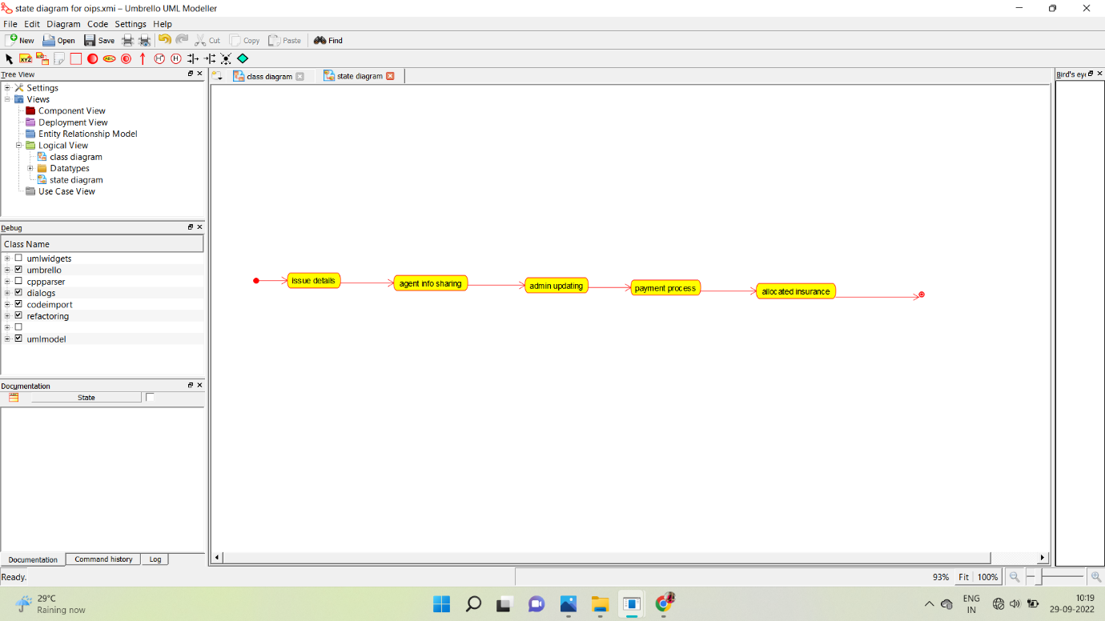

**COMPONENT DIAGRAM:**

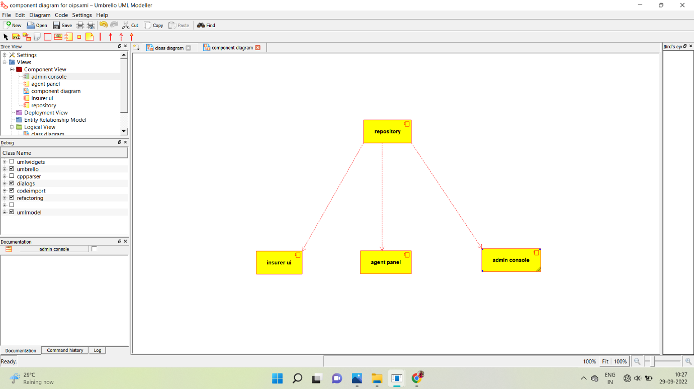

**DEPLOYMENT DIAGRAM:**

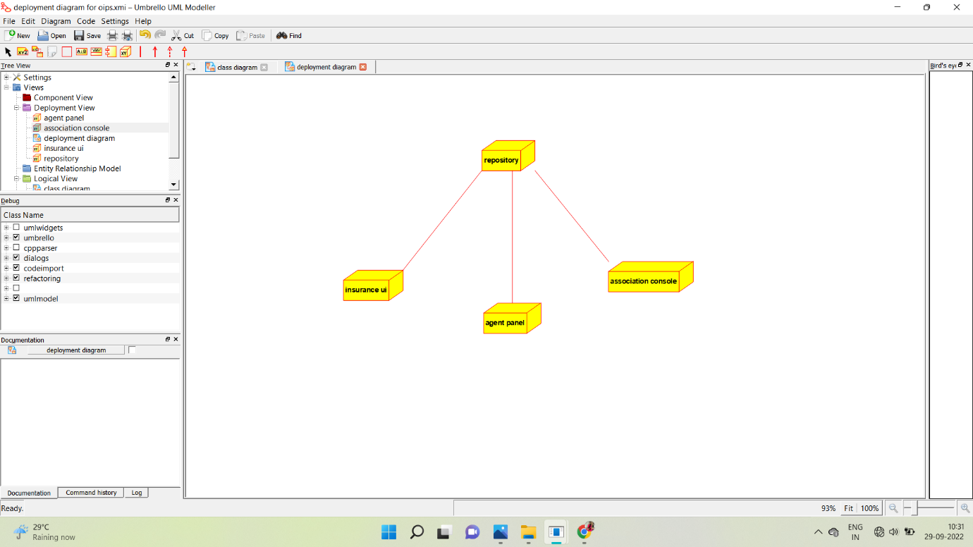

**PROGRAM:**

**/\*\***

**\* Class admin**

**\*/**

**public class admin {**

**//**

**// Fields**

**//**

**private void check_details;**

**private void maintain_db;**

**//**

**// Constructors**

**//**

**public admin () { };**

**//**

**// Methods**

**//**

**//**

**// Accessor methods**

**//**

**/\*\***

**\* Set the value of check_details**

**\* @param newVar the new value of check_details**

**\*/**

**private void setCheck_details (void newVar) {**

**check_details = newVar;**

**}**

**/\*\***

**\* Get the value of check_details**

**\* @return the value of check_details**

**\*/**

**private void getCheck_details () {**

**return check_details;**

**}**

**/\*\***

**\* Set the value of maintain_db**

**\* @param newVar the new value of maintain_db**

**\*/**

**private void setMaintain_db (void newVar) {**

**maintain_db = newVar;**

**}**

**/\*\***

**\* Get the value of maintain_db**

**\* @return the value of maintain_db**

**\*/**

**private void getMaintain_db () {**

**return maintain_db;**

**}**

**//**

**// Other methods**

**//**

**/\*\***

**\*/**

**public void verify_all_the_details()**

**{**

**}**

**/\*\***

**\*/**

**public void maintain_the_database()**

**{**

**}**

**}**

**/\*\***

**\* Class agent**

**\*/**

**public class agent {**

**//**

**// Fields**

**//**

**private void collect_insurer_details;**

**private void allocate_insurance_commission_details;**

**//**

**// Constructors**

**//**

**public agent () { };**

**//**

**// Methods**

**//**

**//**

**// Accessor methods**

**//**

**/\*\***

**\* Set the value of collect_insurer_details**

**\* @param newVar the new value of collect_insurer_details**

**\*/**

**private void setCollect_insurer_details (void newVar) {**

**collect_insurer_details = newVar;**

**}**

**/\*\***

**\* Get the value of collect_insurer_details**

**\* @return the value of collect_insurer_details**

**\*/**

**private void getCollect_insurer_details () {**

**return collect_insurer_details;**

**}**

**/\*\***

**\* Set the value of allocate_insurance_commission_details**

**\* @param newVar the new value of allocate_insurance_commission_details**

**\*/**

**private void setAllocate_insurance_commission_details (void newVar) {**

**allocate_insurance_commission_details = newVar;**

**}**

**/\*\***

**\* Get the value of allocate_insurance_commission_details**

**\* @return the value of allocate_insurance_commission_details**

**\*/**

**private void getAllocate_insurance_commission_details () {**

**return allocate_insurance_commission_details;**

**}**

**//**

**// Other methods**

**//**

**/\*\***

**\*/**

**public void verify_insurer_details()**

**{**

**}**

**/\*\***

**\*/**

**public void sanction_insurance()**

**{**

**}**

**/\*\***

**\*/**

**public void do_payment_after_commission()**

**{**

**}**

**}**

**/\*\***

**\* Class database**

**\*/**

**public class database {**

**//**

**// Fields**

**//**

**private void insurance_details;**

**private void insurer_details;**

**private void validity;**

**private void payment_info;**

**//**

**// Constructors**

**//**

**public database () { };**

**//**

**// Methods**

**//**

**//**

**// Accessor methods**

**//**

**/\*\***

**\* Set the value of insurance_details**

**\* @param newVar the new value of insurance_details**

**\*/**

**private void setInsurance_details (void newVar) {**

**insurance_details = newVar;**

**}**

**/\*\***

**\* Get the value of insurance_details**

**\* @return the value of insurance_details**

**\*/**

**private void getInsurance_details () {**

**return insurance_details;**

**}**

**/\*\***

**\* Set the value of insurer_details**

**\* @param newVar the new value of insurer_details**

**\*/**

**private void setInsurer_details (void newVar) {**

**insurer_details = newVar;**

**}**

**/\*\***

**\* Get the value of insurer_details**

**\* @return the value of insurer_details**

**\*/**

**private void getInsurer_details () {**

**return insurer_details;**

**}**

**/\*\***

**\* Set the value of validity**

**\* @param newVar the new value of validity**

**\*/**

**private void setValidity (void newVar) {**

**validity = newVar;**

**}**

**/\*\***

**\* Get the value of validity**

**\* @return the value of validity**

**\*/**

**private void getValidity () {**

**return validity;**

**}**

**/\*\***

**\* Set the value of payment_info**

**\* @param newVar the new value of payment_info**

**\*/**

**private void setPayment_info (void newVar) {**

**payment_info = newVar;**

**}**

**/\*\***

**\* Get the value of payment_info**

**\* @return the value of payment_info**

**\*/**

**private void getPayment_info () {**

**return payment_info;**

**}**

**//**

**// Other methods**

**//**

**/\*\***

**\*/**

**public void collect_insurance_details()**

**{**

**}**

**/\*\***

**\*/**

**public void verify_insurance()**

**{**

**}**

**/\*\***

**\*/**

**public void check_validity()**

**{**

**}**

**/\*\***

**\*/**

**public void verify_payment()**

**{**

**}**

**}**

**/\*\***

**\* Class insurance**

**\*/**

**public class insurance {**

**//**

**// Fields**

**//**

**private void insurance_info;**

**private void payment;**

**//**

**// Constructors**

**//**

**public insurance () { };**

**//**

**// Methods**

**//**

**//**

**// Accessor methods**

**//**

**/\*\***

**\* Set the value of insurance_info**

**\* @param newVar the new value of insurance_info**

**\*/**

**private void setInsurance_info (void newVar) {**

**insurance_info = newVar;**

**}**

**/\*\***

**\* Get the value of insurance_info**

**\* @return the value of insurance_info**

**\*/**

**private void getInsurance_info () {**

**return insurance_info;**

**}**

**/\*\***

**\* Set the value of payment**

**\* @param newVar the new value of payment**

**\*/**

**private void setPayment (void newVar) {**

**payment = newVar;**

**}**

**/\*\***

**\* Get the value of payment**

**\* @return the value of payment**

**\*/**

**private void getPayment () {**

**return payment;**

**}**

**//**

**// Other methods**

**//**

**/\*\***

**\*/**

**public void give_correct_insurance_info()**

**{**

**}**

**/\*\***

**\*/**

**public void do_the_payment()**

**{**

**}**

**}**

**USE CASE DIAGRAM:**

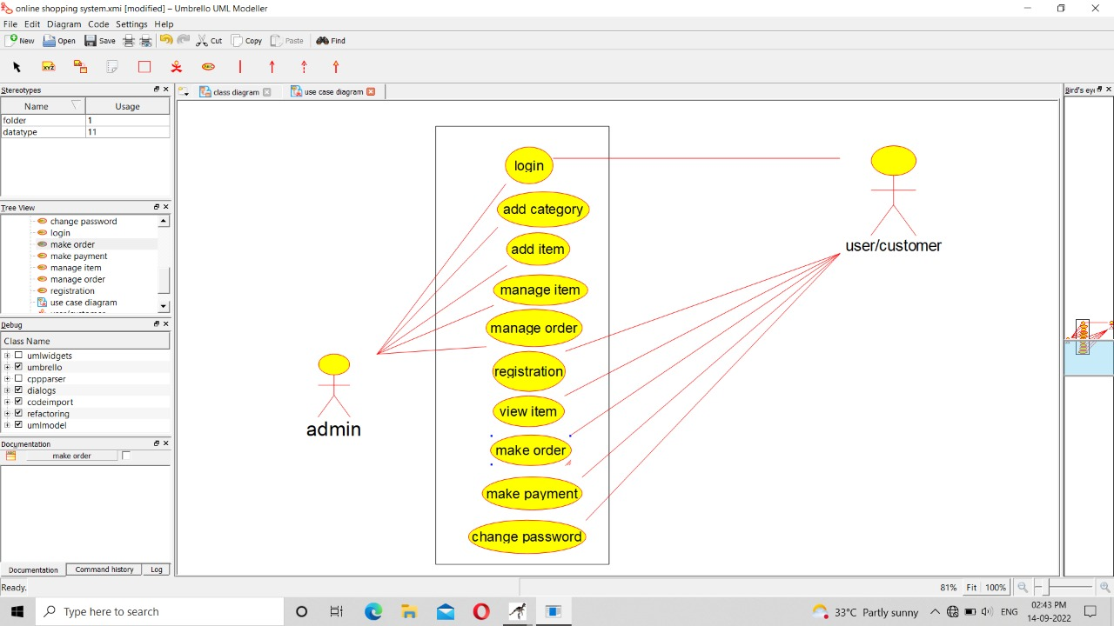

**CLASS DIAGRAM:**

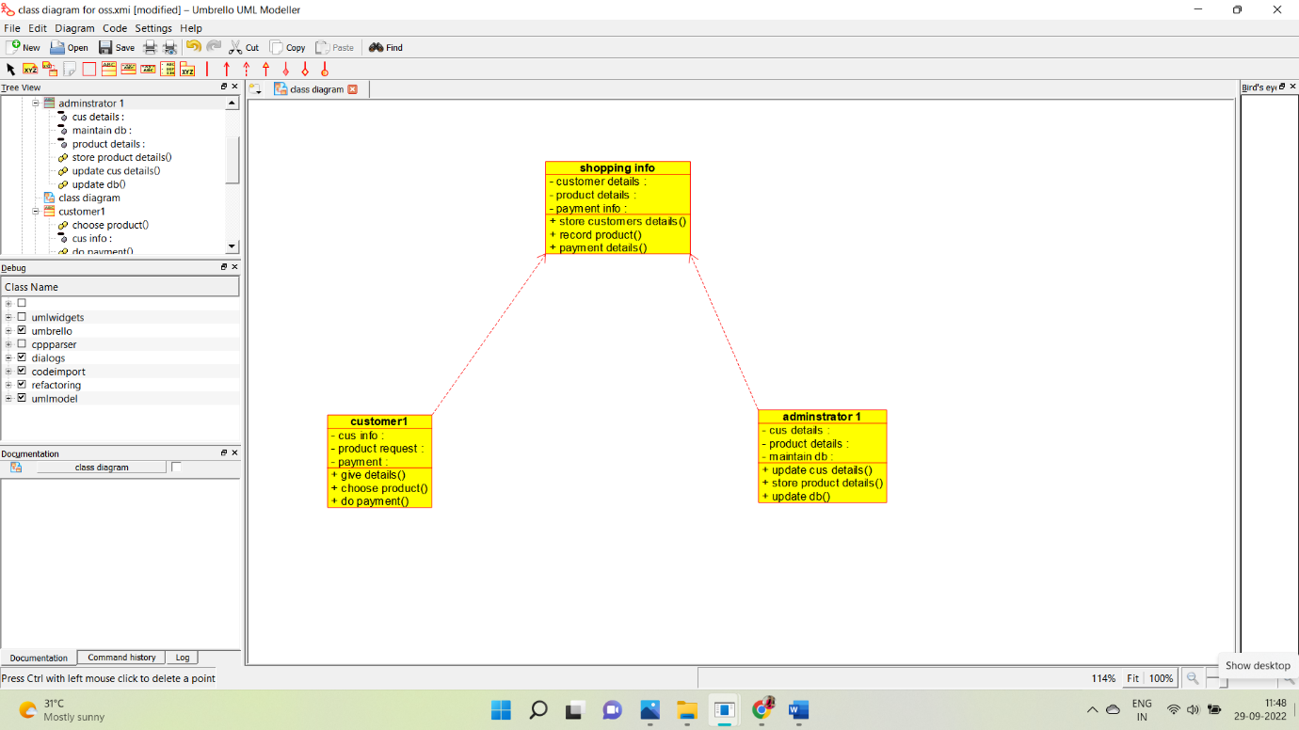

**ACTIVITY DIAGRAM:**

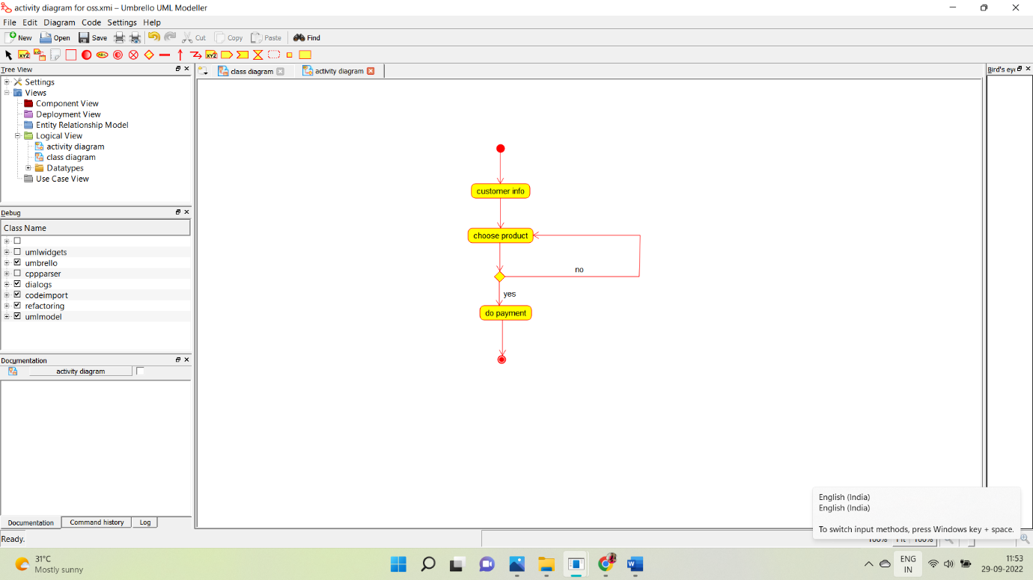

**SEQUENCE DIAGRAM:**

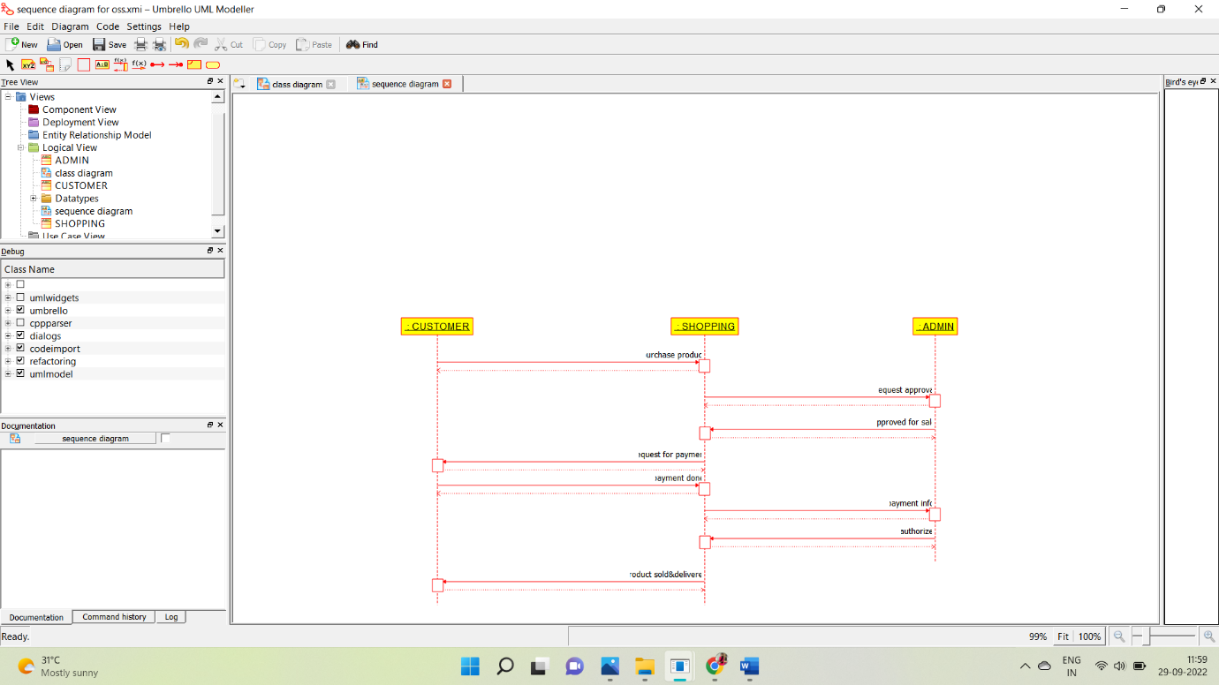

**COLLABORATION DIAGRAM:**

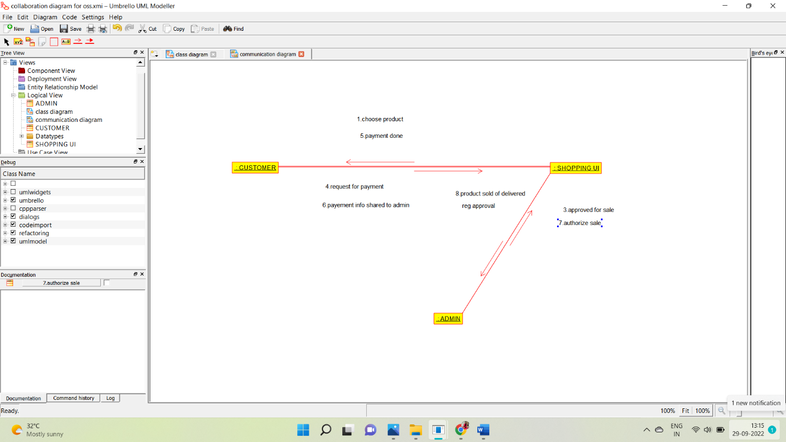

**STATE CHART DIAGRAM:**

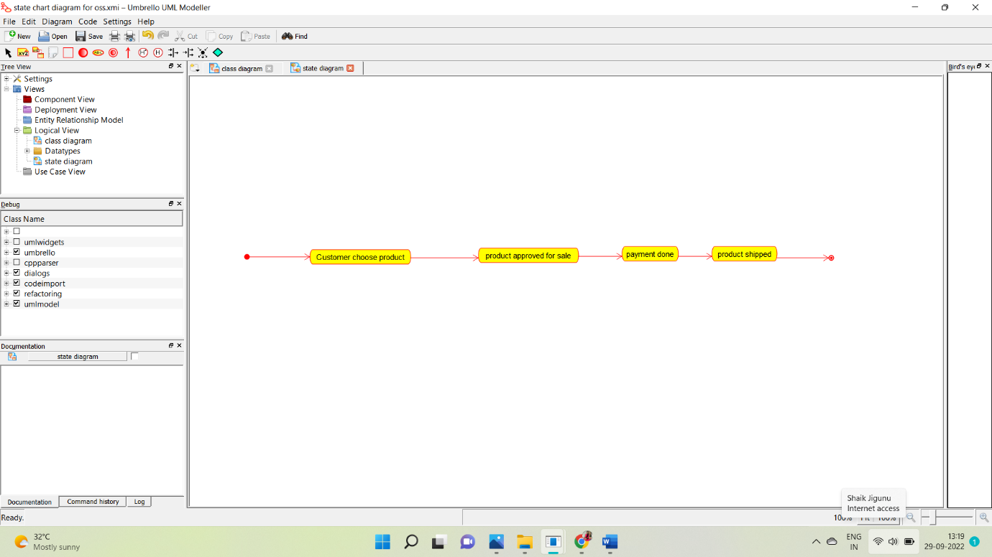

**COMPONENT DIAGRAM:**

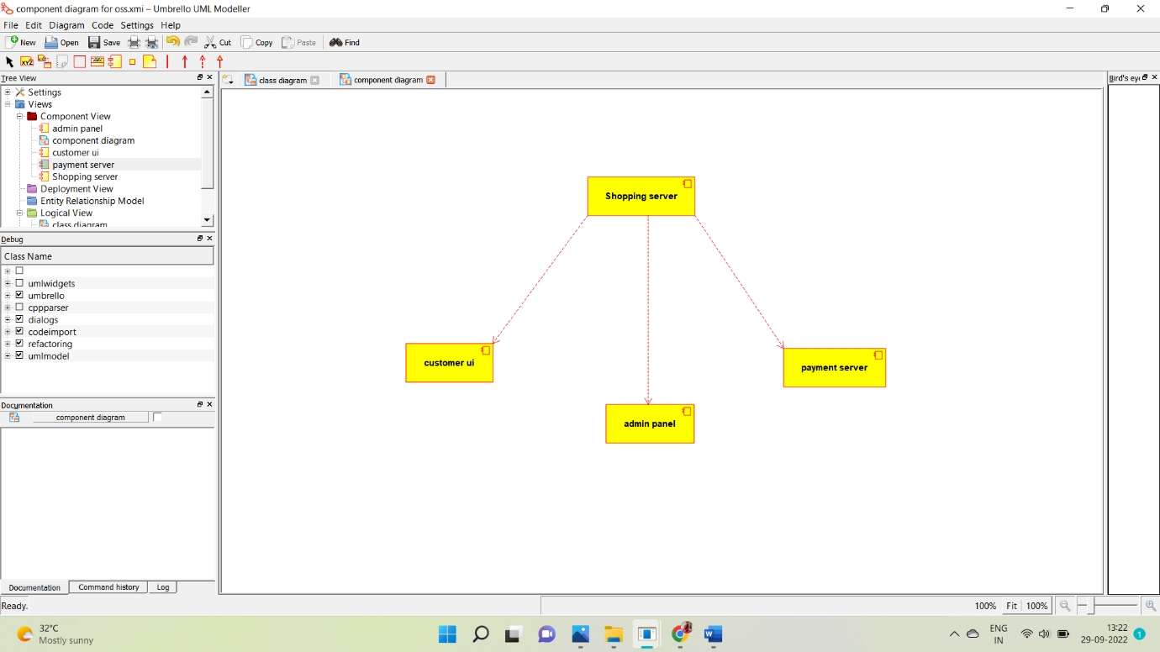

**DEPLOYMENT DIAGRAM:**

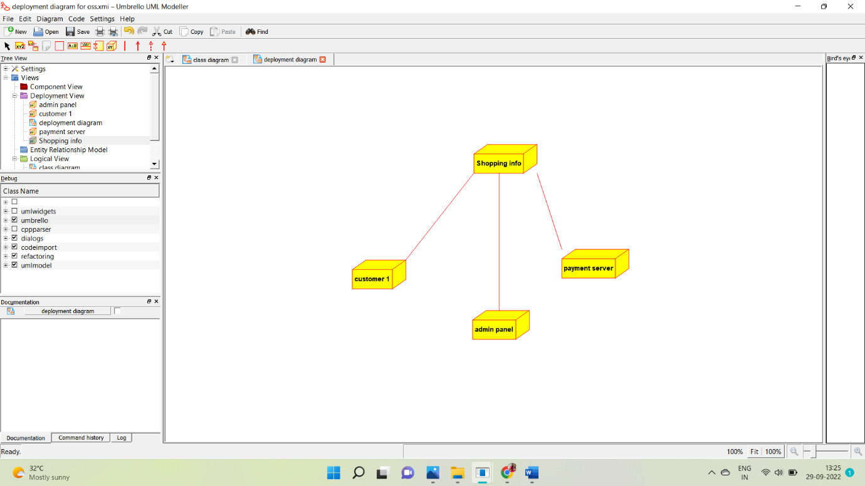

**PROGRAM:**

**/\*\***

**\* Class shopping_info**

**\*/**

**public class shopping_info {**

**//**

**// Fields**

**//**

**private void customer_details;**

**private void product_details;**

**private void payment_info;**

**//**

**// Constructors**

**//**

**public shopping_info () { };**

**//**

**// Methods**

**//**

**//**

**// Accessor methods**

**//**

**/\*\***

**\* Set the value of customer_details**

**\* @param newVar the new value of customer_details**

**\*/**

**private void setCustomer_details (void newVar) {**

**customer_details = newVar;**

**}**

**/\*\***

**\* Get the value of customer_details**

**\* @return the value of customer_details**

**\*/**

**private void getCustomer_details () {**

**return customer_details;**

**}**

**/\*\***

**\* Set the value of product_details**

**\* @param newVar the new value of product_details**

**\*/**

**private void setProduct_details (void newVar) {**

**product_details = newVar;**

**}**

**/\*\***

**\* Get the value of product_details**

**\* @return the value of product_details**

**\*/**

**private void getProduct_details () {**

**return product_details;**

**}**

**/\*\***

**\* Set the value of payment_info**

**\* @param newVar the new value of payment_info**

**\*/**

**private void setPayment_info (void newVar) {**

**payment_info = newVar;**

**}**

**/\*\***

**\* Get the value of payment_info**

**\* @return the value of payment_info**

**\*/**

**private void getPayment_info () {**

**return payment_info;**

**}**

**//**

**// Other methods**

**//**

**/\*\***

**\*/**

**public void store_customers_details()**

**{**

**}**

**/\*\***

**\*/**

**public void record_product()**

**{**

**}**

**/\*\***

**\*/**

**public void payment_details()**

**{**

**}**

**}**

**/\*\***

**\* Class customer1**

**\*/**

**public class customer1 {**

**//**

**// Fields**

**//**

**private void cus_info;**

**private void product_request;**

**private void payment;**

**//**

**// Constructors**

**//**

**public customer1 () { };**

**//**

**// Methods**

**//**

**//**

**// Accessor methods**

**//**

**/\*\***

**\* Set the value of cus_info**

**\* @param newVar the new value of cus_info**

**\*/**

**private void setCus_info (void newVar) {**

**cus_info = newVar;**

**}**

**/\*\***

**\* Get the value of cus_info**

**\* @return the value of cus_info**

**\*/**

**private void getCus_info () {**

**return cus_info;**

**}**

**/\*\***

**\* Set the value of product_request**

**\* @param newVar the new value of product_request**

**\*/**

**private void setProduct_request (void newVar) {**

**product_request = newVar;**

**}**

**/\*\***

**\* Get the value of product_request**

**\* @return the value of product_request**

**\*/**

**private void getProduct_request () {**

**return product_request;**

**}**

**/\*\***

**\* Set the value of payment**

**\* @param newVar the new value of payment**

**\*/**

**private void setPayment (void newVar) {**

**payment = newVar;**

**}**

**/\*\***

**\* Get the value of payment**

**\* @return the value of payment**

**\*/**

**private void getPayment () {**

**return payment;**

**}**

**//**

**// Other methods**

**//**

**/\*\***

**\*/**

**public void give_details()**

**{**

**}**

**/\*\***

**\*/**

**public void choose_product()**

**{**

**}**

**/\*\***

**\*/**

**public void do_payment()**

**{**

**}**

**}**

**/\*\***

**\* Class adminstrator_1**

**\*/**

**public class adminstrator_1 {**

**//**

**// Fields**

**//**

**private void cus_details;**

**private void product_details;**

**private void maintain_db;**

**//**

**// Constructors**

**//**

**public adminstrator_1 () { };**

**//**

**// Methods**

**//**

**//**

**// Accessor methods**

**//**

**/\*\***

**\* Set the value of cus_details**

**\* @param newVar the new value of cus_details**

**\*/**

**private void setCus_details (void newVar) {**

**cus_details = newVar;**

**}**

**/\*\***

**\* Get the value of cus_details**

**\* @return the value of cus_details**

**\*/**

**private void getCus_details () {**

**return cus_details;**

**}**

**/\*\***

**\* Set the value of product_details**

**\* @param newVar the new value of product_details**

**\*/**

**private void setProduct_details (void newVar) {**

**product_details = newVar;**

**}**

**/\*\***

**\* Get the value of product_details**

**\* @return the value of product_details**

**\*/**

**private void getProduct_details () {**

**return product_details;**

**}**

**/\*\***

**\* Set the value of maintain_db**

**\* @param newVar the new value of maintain_db**

**\*/**

**private void setMaintain_db (void newVar) {**

**maintain_db = newVar;**

**}**

**/\*\***

**\* Get the value of maintain_db**

**\* @return the value of maintain_db**

**\*/**

**private void getMaintain_db () {**

**return maintain_db;**

**}**

**//**

**// Other methods**

**//**

**/\*\***

**\*/**

**public void update_cus_details()**

**{**

**}**

**/\*\***

**\*/**

**public void store_product_details()**

**{**

**}**

**/\*\***

**\*/**

**public void update_db()**

**{**

**}**

**}**

*EXPERIMENT 24: ONLINE STOCK MONITORING SYSTEM*

USE CASE DIAGRAM:

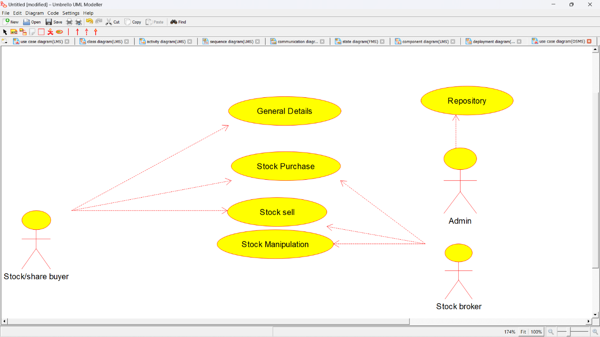

CLASS DIAGRAM: 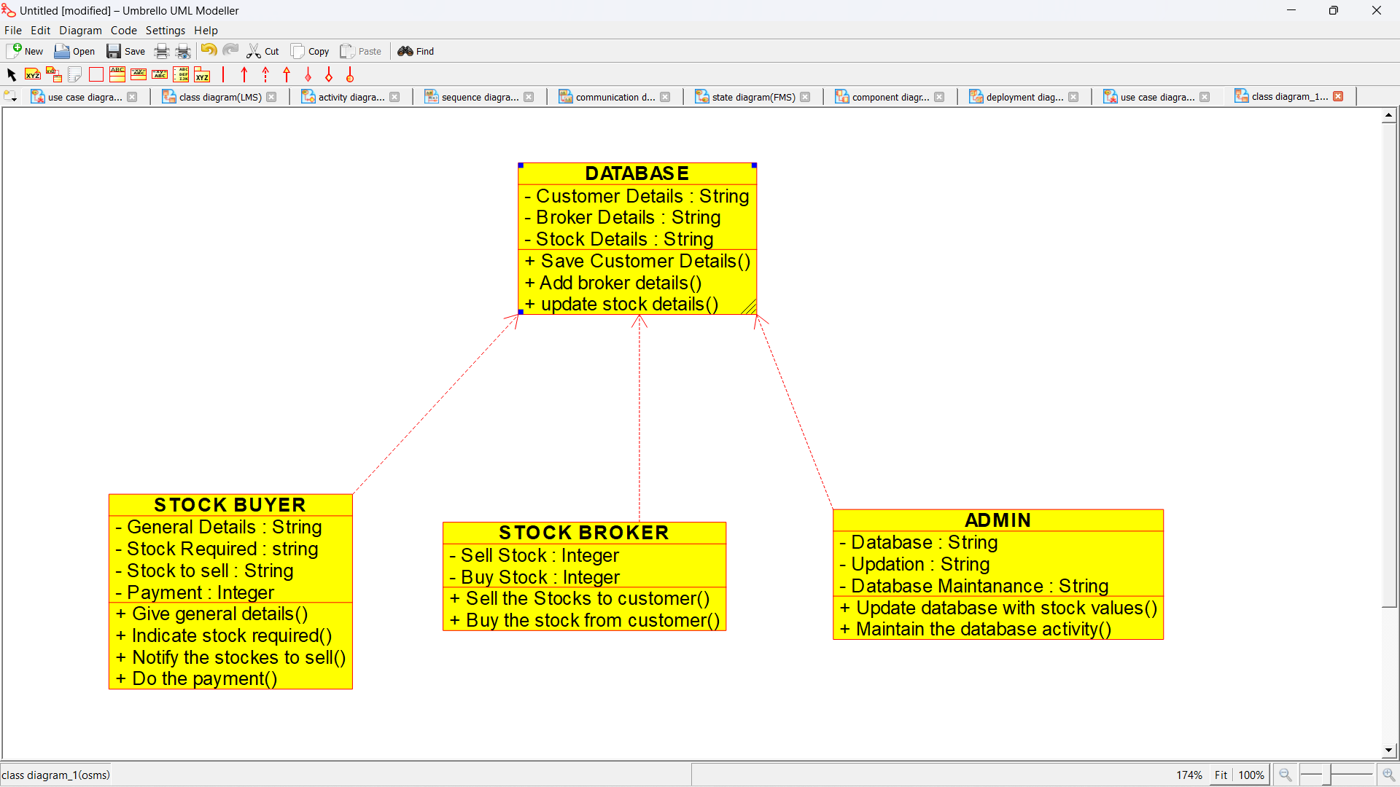

ACTIVITY DIAGRAM:

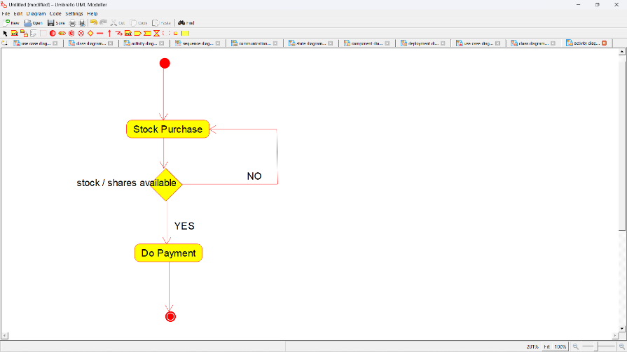

SEQUENCE DIAGRAM:

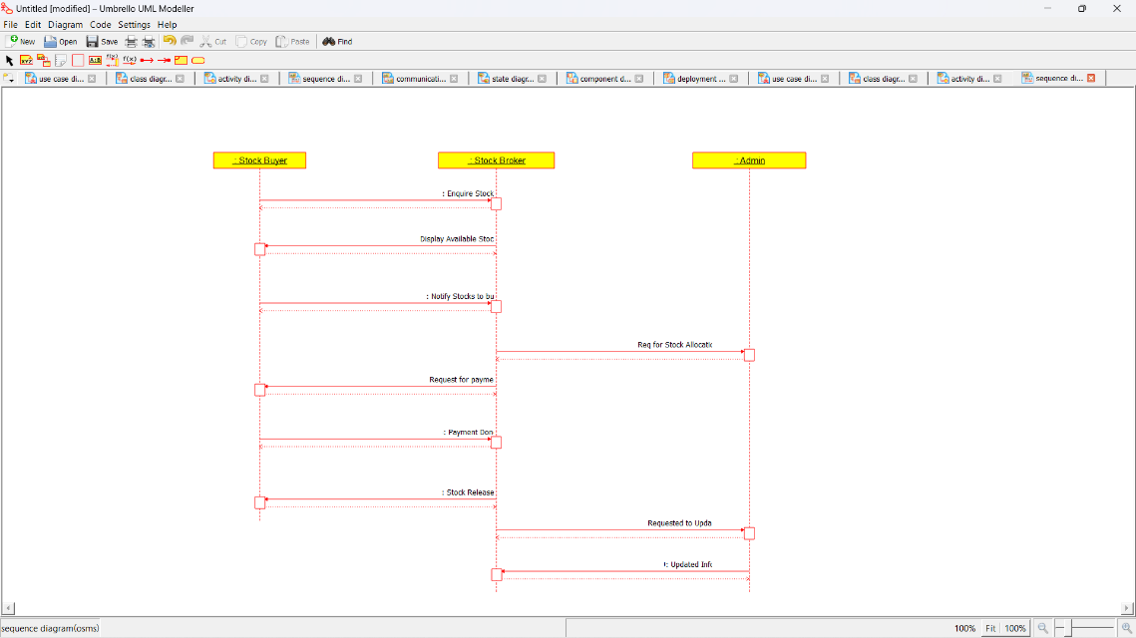

COLLABORATION DIAGRAM:

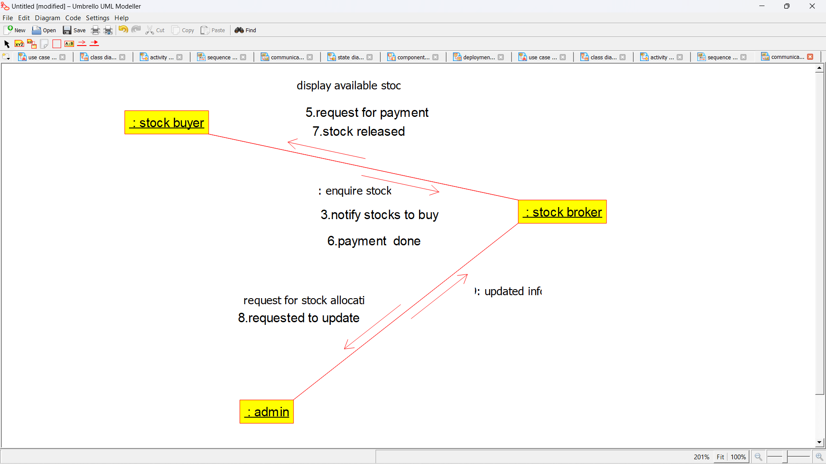

STATE CHART DIAGRAM:

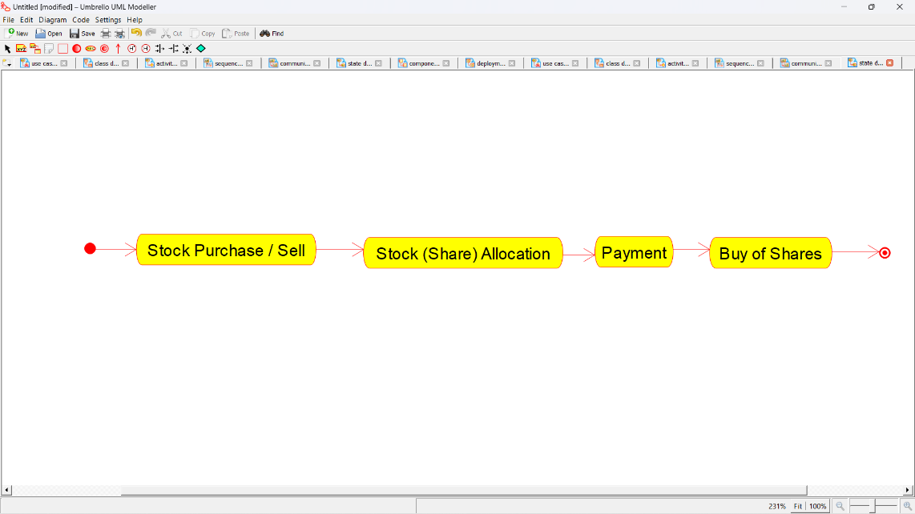

COMPONENT DIAGRAM:

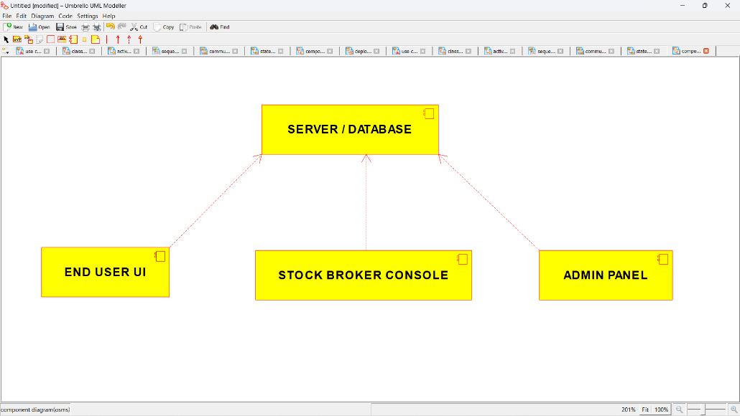

DEPLOYMENT DIAGRAM:

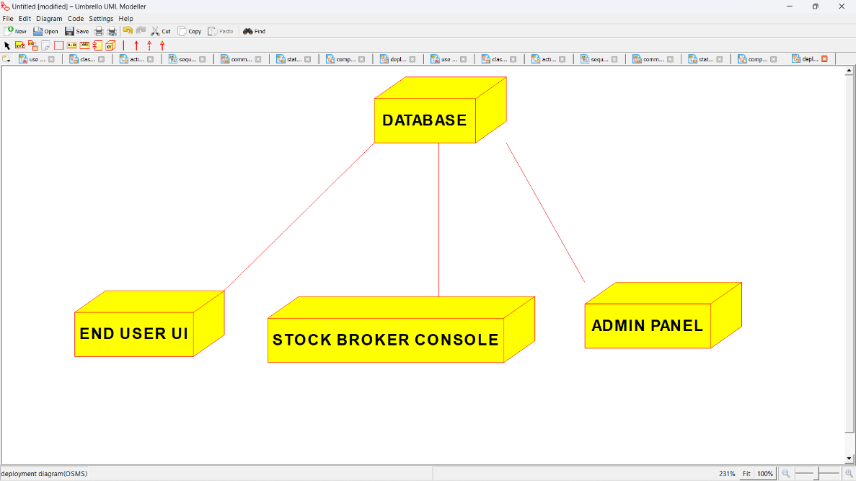

*PROGRAM CODING:*

/**

* Class ADMIN

*/

public class ADMIN {

//

// Fields

//

private String Database;

private String Updation;

private String Database_Maintanance;

//

// Constructors

//

public ADMIN () { };

//

// Methods

//

//

// Accessor methods

//

/**

* Set the value of Database

* @param newVar the new value of Database

*/

private void setDatabase (String newVar) {

Database = newVar;

}

/**

* Get the value of Database

* @return the value of Database

*/

private String getDatabase () {

return Database;

}

/**

* Set the value of Updation

* @param newVar the new value of Updation

*/

private void setUpdation (String newVar) {

Updation = newVar;

}

/**

* Get the value of Updation

* @return the value of Updation

*/

private String getUpdation () {

return Updation;

}

/**

* Set the value of Database_Maintanance

* @param newVar the new value of Database_Maintanance

*/

private void setDatabase_Maintanance (String newVar) {

Database_Maintanance = newVar;

}

/**

* Get the value of Database_Maintanance

* @return the value of Database_Maintanance

*/

private String getDatabase_Maintanance () {

return Database_Maintanance;

}

//

// Other methods

//

/**

*/

public void Update_database_with_stock_values()

{

}

/**

*/

public void Maintain_the_database_activity()

{

}

}

/**

* Class DATABASE

*/

public class DATABASE {

//

// Fields

//

private String Customer_Details;

private String Broker_Details;

private String Stock_Details;

//

// Constructors

//

public DATABASE () { };

//

// Methods

//

//

// Accessor methods

//

/**

* Set the value of Customer_Details

* @param newVar the new value of Customer_Details

*/

private void setCustomer_Details (String newVar) {

Customer_Details = newVar;

}

/**

* Get the value of Customer_Details

* @return the value of Customer_Details

*/

private String getCustomer_Details () {

return Customer_Details;

}

/**

* Set the value of Broker_Details

* @param newVar the new value of Broker_Details

*/

private void setBroker_Details (String newVar) {

Broker_Details = newVar;

}

/**

* Get the value of Broker_Details

* @return the value of Broker_Details

*/

private String getBroker_Details () {

return Broker_Details;

}

/**

* Set the value of Stock_Details

* @param newVar the new value of Stock_Details

*/

private void setStock_Details (String newVar) {

Stock_Details = newVar;

}

/**

* Get the value of Stock_Details

* @return the value of Stock_Details

*/

private String getStock_Details () {

return Stock_Details;

}

//

// Other methods

//

/**

*/

public void Save_Customer_Details()

{

}

/**

*/

public void Add_broker_details()

{

}

/**

*/

public void update_stock_details()

{

}

}

/**

* Class STOCK_BROKER

*/

public class STOCK_BROKER {

//

// Fields

//

private Integer Sell_Stock;

private Integer Buy_Stock;

//

// Constructors

//

public STOCK_BROKER () { };

//

// Methods

//

//

// Accessor methods

//

/**

* Set the value of Sell_Stock

* @param newVar the new value of Sell_Stock

*/

private void setSell_Stock (Integer newVar) {

Sell_Stock = newVar;

}

/**

* Get the value of Sell_Stock

* @return the value of Sell_Stock

*/

private Integer getSell_Stock () {

return Sell_Stock;

}

/**

* Set the value of Buy_Stock

* @param newVar the new value of Buy_Stock

*/

private void setBuy_Stock (Integer newVar) {

Buy_Stock = newVar;

}

/**

* Get the value of Buy_Stock

* @return the value of Buy_Stock

*/

private Integer getBuy_Stock () {

return Buy_Stock;

}

//

// Other methods

//

/**

*/

public void Sell_the_Stocks_to_customer()

{

}

/**

*/

public void Buy_the_stock_from_customer()

{

}

}

/**

* Class STOCK_BUYER

*/

public class STOCK_BUYER {

//

// Fields

//

private String General_Details;

private String Stock_Required;

private String Stock_to_sell;

private Integer Payment;

//

// Constructors

//

public STOCK_BUYER () { };

//

// Methods

//

//

// Accessor methods

//

/**

* Set the value of General_Details

* @param newVar the new value of General_Details

*/

private void setGeneral_Details (String newVar) {

General_Details = newVar;

}

/**

* Get the value of General_Details

* @return the value of General_Details

*/

private String getGeneral_Details () {

return General_Details;

}

/**

* Set the value of Stock_Required

* @param newVar the new value of Stock_Required

*/

private void setStock_Required (String newVar) {

Stock_Required = newVar;

}

/**

* Get the value of Stock_Required

* @return the value of Stock_Required

*/

private String getStock_Required () {

return Stock_Required;

}

/**

* Set the value of Stock_to_sell

* @param newVar the new value of Stock_to_sell

*/

private void setStock_to_sell (String newVar) {

Stock_to_sell = newVar;

}

/**

* Get the value of Stock_to_sell

* @return the value of Stock_to_sell

*/

private String getStock_to_sell () {

return Stock_to_sell;

}

/**

* Set the value of Payment

* @param newVar the new value of Payment

*/

private void setPayment (Integer newVar) {

Payment = newVar;

}

/**

* Get the value of Payment

* @return the value of Payment

*/

private Integer getPayment () {

return Payment;

}

//

// Other meth

//

/**

*/

public void Give_general_details()

{

}

/**

*/

public void Indicate_stock_required()

{

}

/**

*/

public void Notify_the_stockes_to_sell()

{

}

/**

*/

public void Do_the_payment()

{

}

}

EX NO 25: ONLINE VOTING SYSTEM

USECASE DIAGRAM:

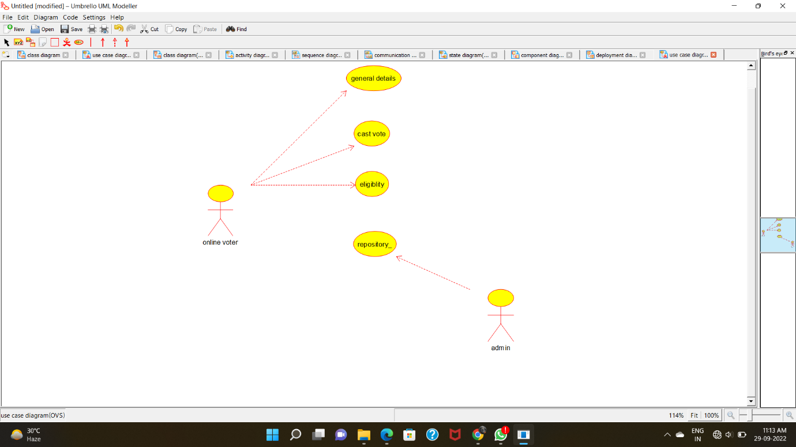

CLASS DIAGRAM:

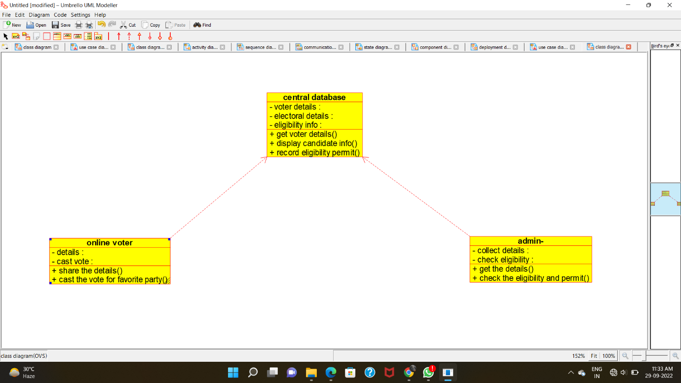

ACTIVITY DIAGRAM:

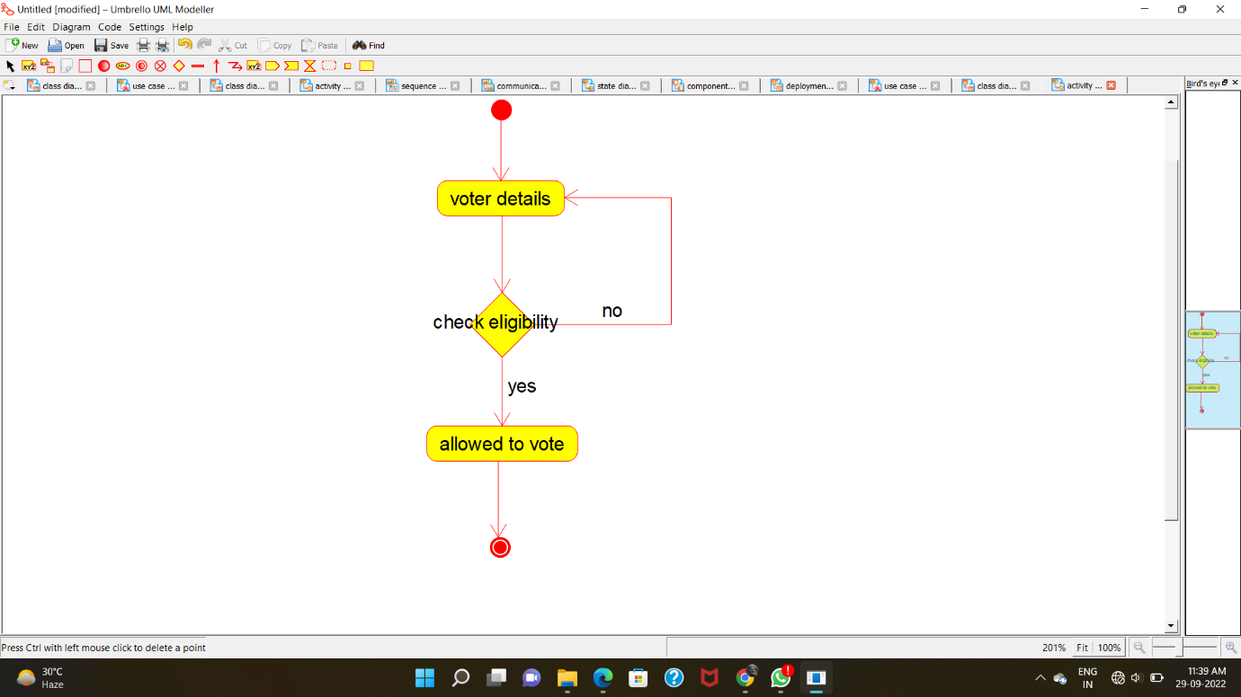

SEQUENCE DIAGRAM:

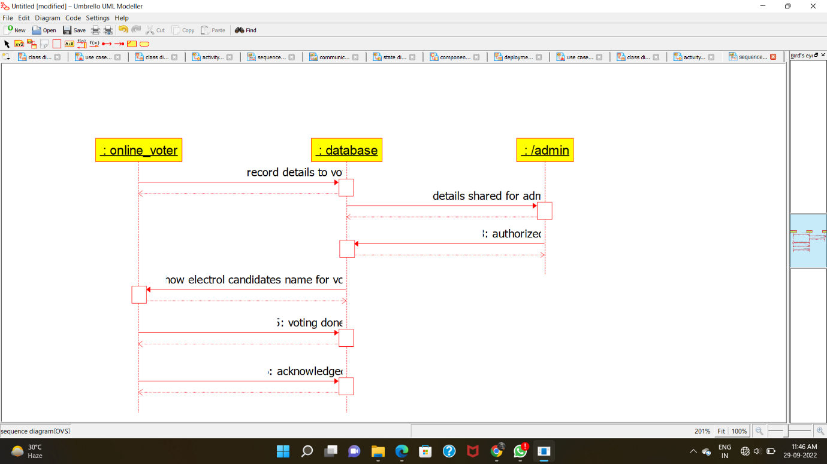

COLLABORATION DIAGRAM:

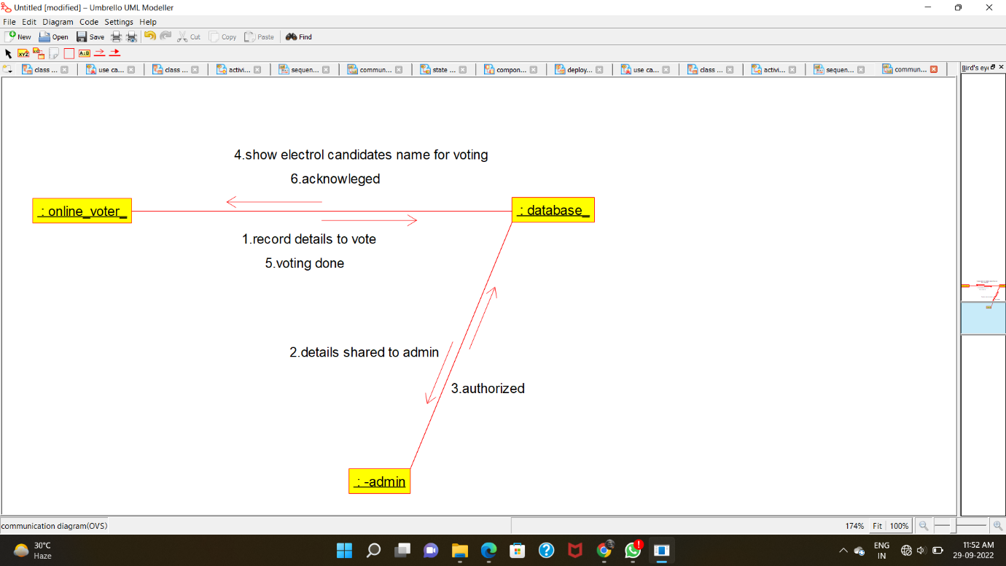

STATE-CHART DIAGRAM:

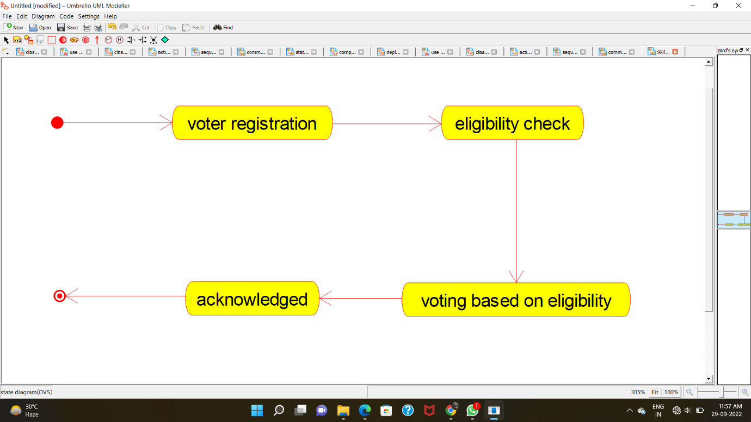

COMPONENT DIAGRAM:

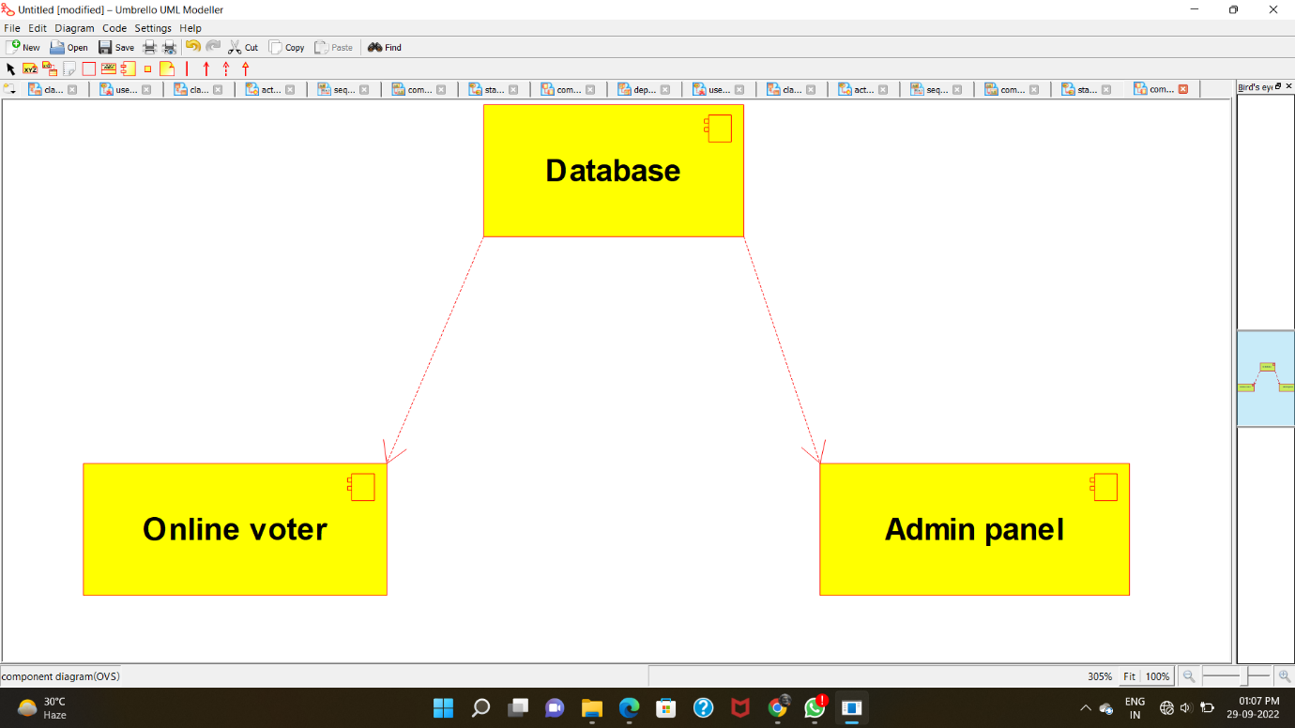

DEPLOYMENT DIAGRAM:

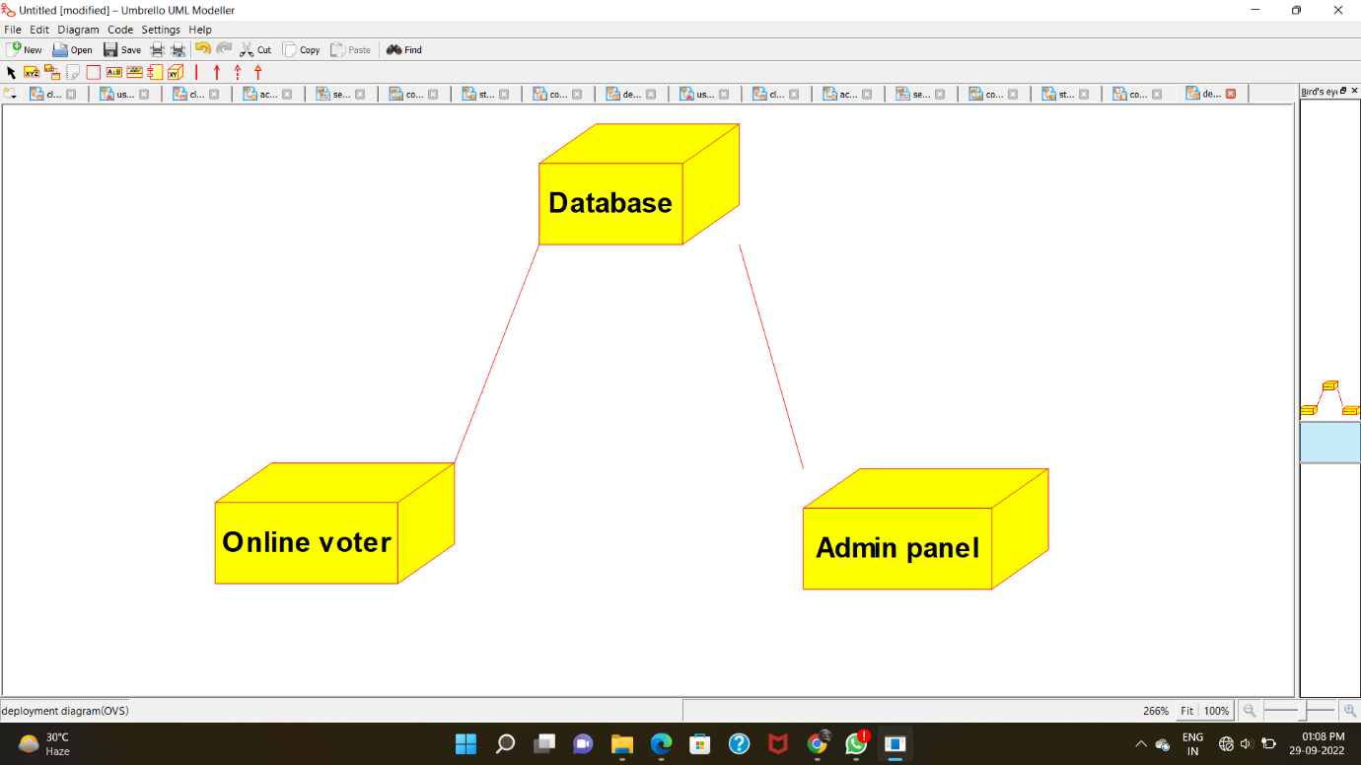

PROGRAM CODE:

CENTRAL DATABASE:

/**

* Class central_database

*/

public class central_database {

//

// Fields

//

private void voter_details;

private void electoral_details;

private void eligibility_info;

//

// Constructors

//

public central_database () { };

//

// Methods

//

//

// Accessor methods

//

/**

* Set the value of voter_details

* @param newVar the new value of voter_details

*/

private void setVoter_details (void newVar) {

voter_details = newVar;

}

/**

* Get the value of voter_details

* @return the value of voter_details

*/

private void getVoter_details () {

return voter_details;

}

/**

* Set the value of electoral_details

* @param newVar the new value of electoral_details

*/

private void setElectoral_details (void newVar) {

electoral_details = newVar;

}

/**

* Get the value of electoral_details

* @return the value of electoral_details

*/

private void getElectoral_details () {

return electoral_details;

}

/**

* Set the value of eligibility_info

* @param newVar the new value of eligibility_info

*/

private void setEligibility_info (void newVar) {

eligibility_info = newVar;

}

/**

* Get the value of eligibility_info

* @return the value of eligibility_info

*/

private void getEligibility_info () {

return eligibility_info;

}

//

// Other methods

//

/**

*/

public void get_voter_details()

{

}

/**

*/

public void display_candidate_info()

{

}

/**

*/

public void record_eligibility_permit()

{

}

ONLINE VOTER:

/**

* Class online_voter

*/

public class online_voter {

//

// Fields

//

private void details;

private void cast_vote;

//

// Constructors

//

public online_voter () { };

//

// Methods

//

//

// Accessor methods

//

/**

* Set the value of details

* @param newVar the new value of details

*/

private void setDetails (void newVar) {

details = newVar;

}

/**

* Get the value of details

* @return the value of details

*/

private void getDetails () {

return details;

}

/**

* Set the value of cast_vote

* @param newVar the new value of cast_vote

*/

private void setCast_vote (void newVar) {

cast_vote = newVar;

}

/**

* Get the value of cast_vote

* @return the value of cast_vote

*/

private void getCast_vote () {

return cast_vote;

}

//

// Other methods

//

/**

*/

public void share_the_details()

{

}

/**

*/

public void cast_the_vote_for_favorite_party()

{

}

}

ADMIN:

/**

* Class admin_

*/

public class admin_ {

//

// Fields

//

private void collect_details;

private void check_eligibility;

//

// Constructors

//

public admin_ () { };

//

// Methods

//

//

// Accessor methods

//

/**

* Set the value of collect_details

* @param newVar the new value of collect_details

*/

private void setCollect_details (void newVar) {

collect_details = newVar;

}

/**

* Get the value of collect_details

* @return the value of collect_details

*/

private void getCollect_details () {

return collect_details;

}

/**

* Set the value of check_eligibility

* @param newVar the new value of check_eligibility

*/

private void setCheck_eligibility (void newVar) {

check_eligibility = newVar;

}

/**

* Get the value of check_eligibility

* @return the value of check_eligibility

*/

private void getCheck_eligibility () {

return check_eligibility;

}

//

// Other methods

//

/**

*/

public void get_the_details()

{

}

/**

*/

public void check_the_eligibility_and_permit()

{

}

}